**The IMDb Movie Ratings & Sentiment Analysis**

**Introduction**

The IMDb Movie Ratings & Sentiment Analysis project involves analyzing movie ratings, genres, and public sentiment to identify trends and patterns. The project aims to answer key questions about movie genres, runtime, and box office success.

Key Questions to Answer:

1. Which genres receive the highest ratings?

2. Does runtime affect movie ratings?

3. Can we predict box office success using metadata?

**Analysis**

Step 1: Exploratory Data Analysis (EDA)

1. Import necessary libraries (Pandas, NumPy, Matplotlib, Seaborn).

2. Load the IMDb movies dataset.

3. Explore data distribution, missing values, and correlations.

4. Visualize top genres, directors, and actors.

Step 2: Genre Analysis

1. Calculate average ratings by genre.

2. Visualize top-rated genres using bar charts.

3. Identify trends and patterns.

Step 3: Runtime Analysis

1. Calculate correlation between runtime and ratings.

2. Visualize using scatter plots.

3. Identify potential relationships.

Step 4: Sentiment Analysis

1. Import NLTK or TextBlob library.

2. Preprocess review text data.

3. Perform sentiment analysis using NLTK or TextBlob.

4. Visualize sentiment distribution using histograms.

**Visualization**

Explore data distribution, missing values, and correlations

**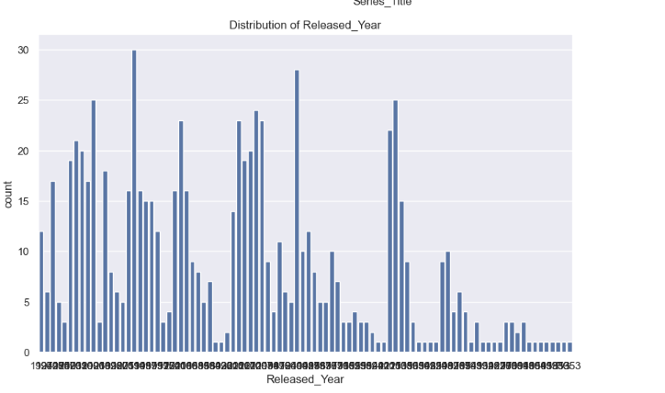 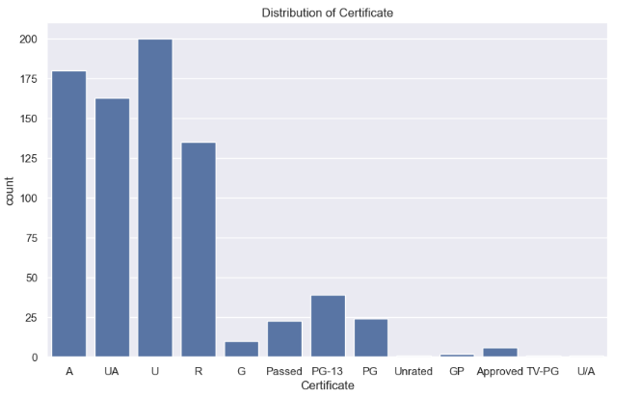 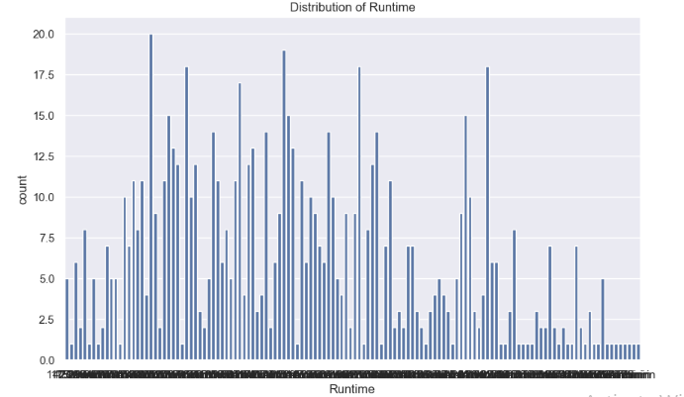 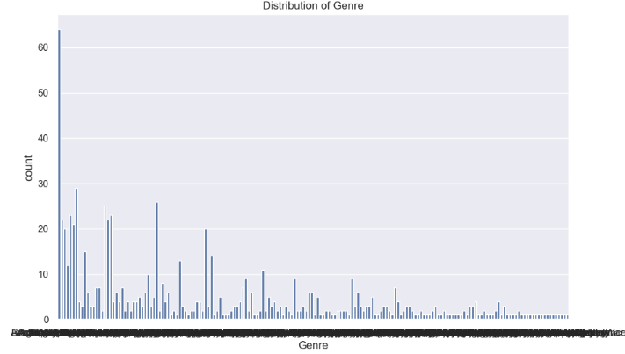 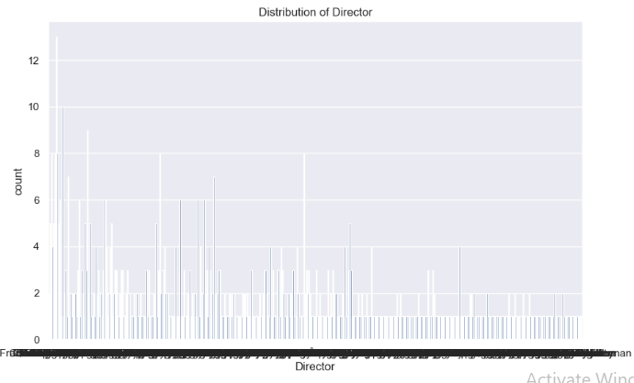 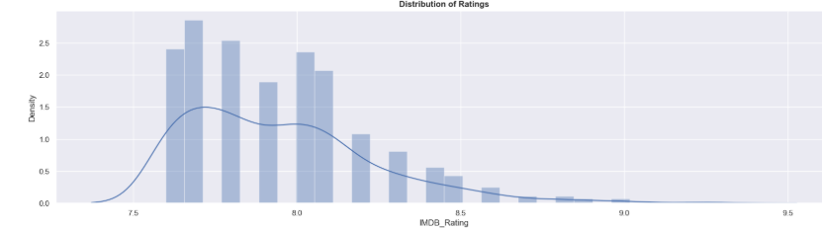**

Genre Analysis

1. Calculate average ratings by genre.

2. Visualize top-rated genres using bar charts.

3. Identify trends and patterns.

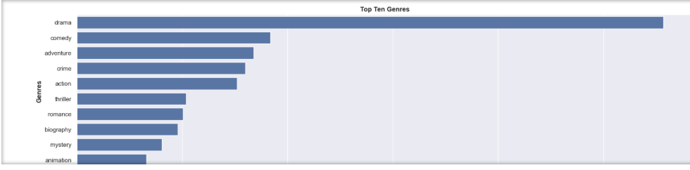

## Runtime Analysis

1. Calculate correlation between runtime and ratings.
2. Visualize using scatter plots.
3. Identify potential relationships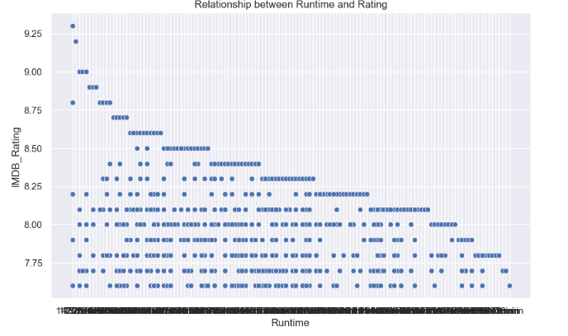
4. Sentiment Analysis[¶](http://localhost:8888/doc/workspaces/auto-V/tree/IMDb%20Movie%20Ratings%20%26%20Sentiment%20Analysis.ipynb?#Sentiment-Analysis)

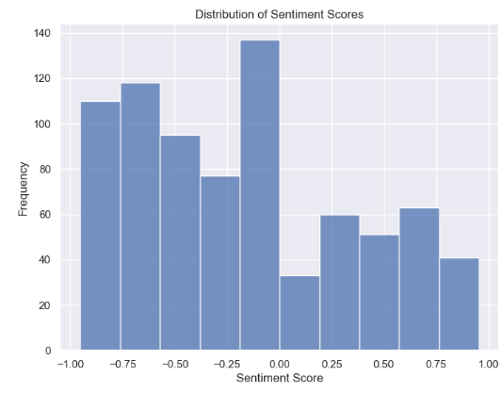

#### Recommendation System (Optional)

Poster\_Link \

2 <https://m.media-amazon.com/images/M/MV5BMTMxNT>...

5 <https://m.media-amazon.com/images/M/MV5BNzA5ZD>...

8 <https://m.media-amazon.com/images/M/MV5BMjAxMz>...

10 [https://m.media-amazon.com/images/M/MV5BN2EyZj](https://m.media-amazon.com/images/M/MV5BN2EyZj" \t "_blank)...

13 [https://m.media-amazon.com/images/M/MV5BZGMxZT](https://m.media-amazon.com/images/M/MV5BZGMxZT" \t "_blank)...

Series\_Title Released\_Year \

2 The Dark Knight 2008

5 The Lord of the Rings: The Return of the King 2003

8 Inception 2010

10 The Lord of the Rings: The Fellowship of the Ring 2001

13 The Lord of the Rings: The Two Towers 2002

Certificate Runtime Genre IMDB\_Rating \

2 UA 152 min Action, Crime, Drama 9.0

5 U 201 min Action, Adventure, Drama 8.9

8 UA 148 min Action, Adventure, Sci-Fi 8.8

10 U 178 min Action, Adventure, Drama 8.8

13 UA 179 min Action, Adventure, Drama 8.7

Overview Meta\_score \

2 When the menace known as the Joker wreaks havo... 84.0

5 Gandalf and Aragorn lead the World of Men agai... 94.0

8 A thief who steals corporate secrets through t... 74.0

10 A meek Hobbit from the Shire and eight compani... 92.0

13 While Frodo and Sam edge closer to Mordor with... 87.0

Director Star1 Star2 \

2 Christopher Nolan Christian Bale Heath Ledger

5 Peter Jackson Elijah Wood Viggo Mortensen

8 Christopher Nolan Leonardo DiCaprio Joseph Gordon-Levitt

10 Peter Jackson Elijah Wood Ian McKellen

13 Peter Jackson Elijah Wood Ian McKellen

Star3 Star4 No\_of\_Votes Gross sentiment

2 Aaron Eckhart Michael Caine 2303232 534,858,444 -0.8176

5 Ian McKellen Orlando Bloom 1642758 377,845,905 -0.4019

8 Elliot Page Ken Watanabe 2067042 292,576,195 -0.7717

10 Orlando Bloom Sean Bean 1661481 315,544,750 0.3612

13 Viggo Mortensen Orlando Bloom 1485555 342,551,365 0.4019